**Cost-Effectiveness of the Interventions in the Primary Prevention of Diabetes Among Asian Indians: A Reevaluation and Extension**

**V 3.0**

Aryan Sharma1, Darsh Devani1, Kush Patel1, Namrata Dalal1, Prabodh Sankhe1, Sreeranjani Menon1

1MCPHS University



**Course:** PEP 814.A Health Care Decision Analysis

**Instructor:** Dr. Brian Rittenhouse

**ABSTRACT**

**INTRODUCTION**

The Indian Diabetes Prevention Programme (IDPP) conducted a three-year study to investigate strategies for preventing type 2 diabetes among individuals with impaired glucose tolerance (IGT). A later Cost-Effectiveness Analysis (CEA) compared four intervention strategies: lifestyle modification (LSM) alone, metformin medication alone, LSM combined with metformin, and a control group receiving standard healthcare advice. The primary objective was to estimate intervention costs and assess cost-effectiveness relative to the control group.

**METHODS**

We recalculated Incremental Cost-Effectiveness Ratios (ICERs) using a systematic method outlined by Glick et al., organizing interventions based on effectiveness and eliminating dominated therapies. We utilized clinical and cost parameters to compute ICERs and employed a Cost-Effectiveness (CE) plane to visually represent cost-effectiveness relationships. Probabilistic Sensitivity Analysis (PSA) assessed decision uncertainty, incorporating variability into model inputs through Monte Carlo simulations. Net Monetary Benefit (NMB) and Cost-Effectiveness Acceptability Curves/Frontiers (CEAC/CEAF) provided insights into intervention cost-effectiveness across different thresholds of Willingness to Pay (WTP). Expected Value of Perfect Information (EVPI) and Net Loss Curves (NLC) analyzed the value of reducing uncertainty and the impact of selecting non-cost-effective treatments.

**RESULTS**

Revised ICER calculations identified LSM as the most cost-effective intervention for preventing diabetes among individuals with IGT, if WTP exceeded $565.15. Probabilistic analysis and CEAC/CEAF corroborated LSM's cost-effectiveness, showing it to be the preferred option at WTP thresholds above $550. LSM demonstrated the highest probability of being cost-effective until $3 million WTP. EVPI analysis suggested further research to reduce decision uncertainty.

**DISCUSSION**

Our findings contradict the original paper's conclusion, highlighting the importance of robust cost-effectiveness analysis methodologies. The variability in results underscores the need for additional research to inform accurate decision-making regarding diabetes prevention strategies.

**CONCLUSION**

While the original CEA suggested LSM followed by metformin as cost-effective, our analysis determined LSM as the preferred option if WTP exceeds $565.15. Our model highlights the necessity for rigorous analysis to guide informed decision-making in healthcare resource allocation. Further research is warranted to address uncertainties and refine cost-effectiveness evaluations.

# INTRODUCTION

The Indian Diabetes Prevention Programme (IDPP) conducted a comprehensive three-year study to investigate strategies for preventing type 2 diabetes among individuals with impaired glucose tolerance (IGT).2 a later Cost-Effectiveness Analysis (CEA) compared four intervention strategies: lifestyle modification (LSM) alone, metformin medication alone, a combination of LSM and metformin medication, and a control group receiving standard healthcare advice.2 The primary objective was to estimate the costs associated with delivering LSM and metformin interventions, and to assess cost-effectiveness relative to the control group as implemented within the framework of IDPP.1

The direct medical cost over the 3-year trial period, the intervention costs per subject were: 2,739 INR ($61) for the control group, 10,136 INR ($225) for LSM, 9,881 INR ($220) for metformin, and 12,144 INR ($270) for LSM combined with metformin. The number of individuals needed to treat to prevent/delay one case of diabetes compared to the control was 6.4 with LSM, 6.9 with metformin, and 6.5 with LSM and metformin. The calculated ICERs for preventing one case of diabetes, with LSM, metformin, and LSM combined with metformin, all compared to the control, were $1,052, $1,095, and $1,359,

respectively.

The study concluded that LSM was the most cost-effective intervention, followed by metformin given that it has a lower ICER. However, we believe this conclusion is incorrect due to flawed methodology of calculating the Incremental Cost-Effectiveness Ratio (ICER), which did not appropriately consider several crucial factors. These errors included deviating from the systematic method for ICER calculation by comparing cost and effectiveness of all interventions only to the control group without ranking the treatments, failure to eliminate dominated treatments, and failing to determine cost effectiveness based on a Willingness-to-Pay (WTP) threshold.3 Consequently, the paper reported an incorrect cost-effectiveness conclusion. Additionally, the authors did not employ a probabilistic sensitivity analysis (PSA) to address the inherent uncertainty in the model parameters and that influence on the confidence in the analytic conclusions – decision uncertainty.

Our primary objective was to recalculate the ICER using a systematic methodology to accurately identify cost-effective treatment.3 We also used a cost-effectiveness (CE) plane and the Net Monetary Benefit (NMB) method for the same goals to confirm all methods yield the same results. Additionally, conduct a PSA to assess decision uncertainty. A PSA also enables us to explore other measures such as Expected Value of Perfect Information (EVPI) and Net Loss (NL) analyses. These show the maximal value of acquiring additional information about the treatments and the consequences of using a treatment that is not cost-effective over one that is – the consequences of an incorrect cost-effectiveness conclusion and its implementation.

# METHODS

## Incremental Cost Effectiveness Ratios

We recalculated Incremental Cost-Effectiveness Ratios (ICERs) according to a systematic method outlined in Glick.3 This method involved a systematic comparison of the costs and effects of different interventions. First, we ranked the treatments from lowest to highest based on their costs and effectiveness. Next, we identified and eliminated dominated therapies, whereby interventions that were clearly less effective and more costly than other alternatives were excluded from further consideration as they cannot be cost-effective if they are inefficient in this way. Additionally, we a CE plane to indicate the relationships between costs and outcomes of the various alternatives.. Following the elimination of dominated therapies, we recalculated the ICERs to accurately assess the incremental cost-effectiveness of the remaining options.

* 1. Clinical Parameters

The authors used unconventional methods to calculate the Incremental Cost-Effectiveness Ratio (ICER). Typically, an ICER is determined by dividing incremental cost by incremental effectiveness. However, the authors used a different approach by using the Number Needed to Treat (NNT) metric for ICER calculation. NNT is often used to measure treatment effectiveness and was calculated by dividing 1 by the absolute risk reduction. Thus, multiplying IC by NNT is equivalent to dividing IC by ARR. In this respect, the use of the NNT calculation was not flawed per se.

However, there are two ways in which this process is not correct. The first, is that use of NNT vs. control, implies the ICER is always calculated vs control. This is not an appropriate process (according to Glick) when more than 2 alternatives are in an economic model; it may be considered generally inappropriate.3 The second way is more subtle and is specific to the case at hand where the analysis frame extends over multiple years and only the result (year 3) is reported. This implies that the path to the year 3 result does not matter. It also implies that discounting cannot occur accurately in such a model where year 1 and 2 values for cost and outcomes are not reported.

Furthermore, the authors drew conclusions regarding the cost-effectiveness of interventions solely based on having the lowest ICER values and without considering the WTP threshold. This might have led to misleading conclusions about the cost-effectiveness of the interventions.  
We utilized the cumulative incidence at year 3 to calculate the probability of developing diabetes each year within the 3-year period. Assuming a constant rate over the 3 years and the cumulative incidence of diabetes of 55% at year 3 as a probability of 0.55 for the control group, we estimated the cumulative incidence at year 1 and year 2. Using the “failure” probabilities of developing diabetes at year 1, 2, and 3, we derived the probabilities of not developing diabetes by subtracting each “failure” probability from 1 (Table 1). These probabilities of not developing diabetes at year 1, 2, and 3 were then used to construct a survival curve. By plotting this curve, we were able to calculate the area under the curve (AUC) between year 0 and 1, between year 1 and 2, and between year 2 and 3 (Figure 1). This provided the life years of diabetes avoided at each respective year for each treatment. The AUC represented the time without disease; in this context, it quantified the impact of the intervention across different time intervals. Summing up these three AUC values gave us the total life years of diabetes avoided for the intervention. We repeated this process for each intervention arm to calculate the total life years of diabetes avoided for comparison, which served as the improved effectiveness measures needed in the improved version of the Incremental Cost-Effectiveness Ratio (ICER) calculations. AUC calculations with respective survival curves for each intervention are available in the appendix section. The survival curve for control group is presented in figure 1.

Figure 1. Survival Curve for Control Group

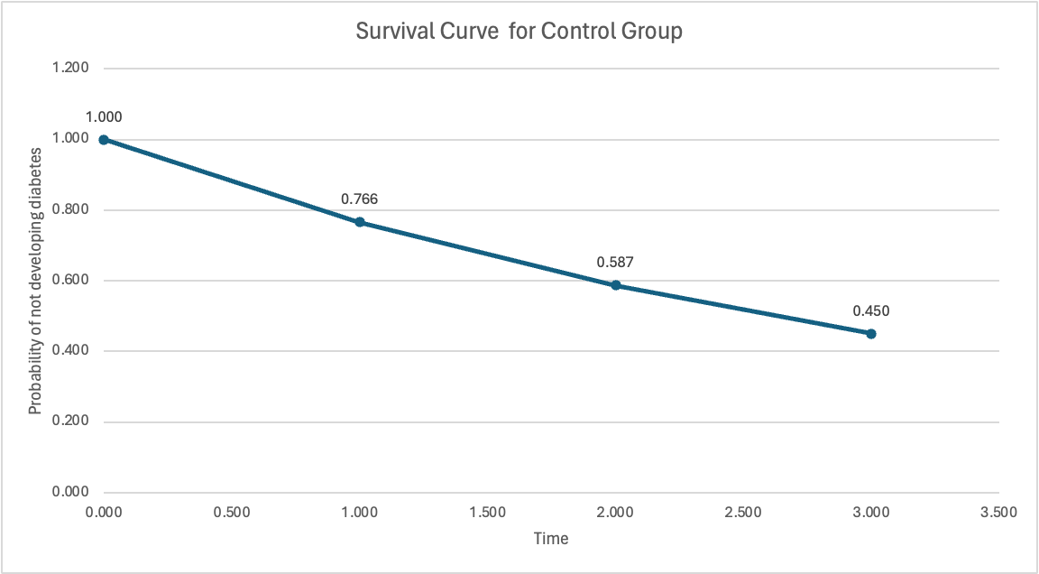

Table 1. Rate and Probability of developing/avoiding diabetes for all interventions at each year

|  |  |  |  |  |  |  |  |  |
| --- | --- | --- | --- | --- | --- | --- | --- | --- |
| Intervention | CI at Year 3 | Rate | Probability of Developing Diabetes | | | Probability of Avoiding Diabetes | | |
| **Year 1** | **Year 2** | **Year 3** | **Year 1** | **Year 2** | **Year 3** |
| Control | 0.55 | 0.266 | 0.234 | 0.413 | 0.55 | 0.766 | 0.587 | 0.45 |
| LSM | 0.393 | 0.166 | 0.153 | 0.283 | 0.393 | 0.847 | 0.717 | 0.607 |
| Met | 0.405 | 0.173 | 0.159 | 0.292 | 0.405 | 0.841 | 0.707 | 0.595 |
| LSM + Met | 0.395 | 0.167 | 0.154 | 0.285 | 0.395 | 0.846 | 0.715 | 0.605 |

CI – cumulative incidence; LSM- lifestyle modification; MET- Metformin

2.3 Cost Parameters.

We obtained the total cost of the intervention LSM, MET, LSM + MET for all the 3 years from the original paper. (Table 2) We did not discount the cost values. All the cost values are in 2006 U.S Dollar. Alpha and Beta values for total cost for each interventions are reported in the appendix section

|  |  |  |  |  |
| --- | --- | --- | --- | --- |
| Cost parameters | | | | |
| Intervention | **Control** | **LSM** | **MET** | **LSM + MET** |
| Total Cost | $61 | $225 | $220 | $270 |

Table 2. Total cost for each intervention at year 3

LSM- lifestyle modification; MET- metformin

## Net Monetary Benefit and Probabilistic Sensitivity Analysis

Net Monetary Benefit represents the value of an intervention in monetary terms when a WTP threshold for a unit of benefit (for example a measure of health outcome or QALY) is known or conjectured. We computed the NMB and its values in the PSA. The NMB allows for the integration of both the benefits and costs of a health intervention into a single value, making it easier to compare interventions. The highest NMB indicates the cost-effective intervention. Utilizing NMB in the PSA incorporates uncertainty in model inputs, showing that influence on outputs and conclusions.

The aim of the PSA was to assess the robustness and reliability of our cost-effectiveness analysis (CEA) under postulated uncertainty about model parameters. We achieved this by incorporating variability into the model's inputs and observing the effects on the output. The variables included in the PSA are those that have inherent uncertainty in the model. These include treatment cost and treatment effectiveness. Each variable was assigned a probability distribution that best reflects its underlying uncertainty.

We performed PSA using Monte Carlo simulations, where all the variables varied simultaneously according to their specified distributions. The optimal treatment was assessed by assessing which treatment shows the maximal average NMB over all PSA iterations at any WTP level. Beta distributions were selected for clinical parameters, such as probabilities of avoiding diabetes, to represent uncertainty and variability, while gamma distributions were chosen for total medical costs to account for their skewed nature and non-negativity in the context of the 3-year trial period. These distributions allow for capturing the inherent uncertainty and variability in the parameters. The alpha and beta values for each interventions are reported in the appendix section (Table S1).

Furthermore, we analyzed Cost-Effectiveness Acceptability Curves/Frontiers (CEAC/Fs). These graphical representations facilitated informed decision-making by offering insights into the probability of various interventions being considered cost-effective across different thresholds of WTP.

## Expected Value of Perfect Information Analysis and Net Loss Curves

Expected Value of Perfect Information analysis was conducted to determine the value of reducing uncertainty. Proceeding the calculation of NMB for each intervention at different WTP, we calculated the average of maximum NMB values from each iteration and subtracted the maximum of the averages of NMBs out of four interventions (i.e. that for the optimal treatment). This gave us the EVPI on a patient level. Similarly, population level EVPI was calculated.

Additionally, Net Loss Curves (NLC) were utilized to assess the impact of implementing any but the cost-effective treatment, which was estimated by subtracting the Average NMB values of each treatment from the average Maximum net benefit. NL for the optimal treatment was less than that for the non-optimal treatments which provided the differences in loss if you implemented one intervention instead of another.

# RESULTS

## 3.1 Incremental cost-effectiveness ratios

We reproduced the Incremental Cost-Effectiveness Ratios (ICER) calculated by the authors (Table 3). First, the Incremental Cost was determined by subtracting the cost of the control group intervention from each intervention's cost (Table 1). To obtain the ICER, we multiplied the Incremental Cost by the Number Needed to Treat (NNT) for each group. The NNT for the LSM group vs. control was 6.4, for the Metformin group was 6.9, and for the LSM + Metformin group was 6.5. This resulted in ICER values of $1,050 for LSM, $1,097 for Metformin, and $1,359 for LSM + Metformin, respectively. These numbers were exactly what were reported by the original authors.

TABLE 3. ICER CALCULATIONS AS PER ORIGINAL CEA MODEL

|  |  |  |  |  |
| --- | --- | --- | --- | --- |
| Intervention | Control | LSM | MET | LSM + MET |
| Total cost for 3 years | $61 | $225 | $219 | $270 |
| NNT | - | 6.4 | 6.9 | 6.5 |
| IC* | - | $164 | $159 | $209 |
| ICER+ | - | $1050 | $1097 | $1359 |

*Total Cost of Intervention – Total Cost of Control; +IC x NNT

ICER – incremental cost-effectiveness ratio; IC – incremental Cost, NNT - number needed to treat/prevent one case of diabetes; LSM – lifestyle modification; Met – metformin.

However, the ICER was determined by comparing the costs and effectiveness of all interventions solely against the control group, without prioritizing treatments or eliminating less effective options. Additionally, the calculation did not incorporate a threshold for WTP. This approach overlooks the systematic evaluation and prioritization of interventions based on their cost-effectiveness in relation to a predefined WTP threshold. The original authors suggested that LSM was the most cost-effective based on it having the lowest ICER vs. control. This was not an appropriate way of calculating ICER and deciding cost-effectiveness.

Instead, we utilized Glick’s method to recalculate the ICER (Table 4)3.Initially, interventions were organized based on increasing order of their effectiveness. In step 1, the LSM + MET intervention was found to be dominated by the LSM intervention due to its higher cost and lower effectiveness (higher NNT values imply lower effectiveness vs control). Following this, in step 2, we reorganized the interventions and calculated their ICER. Notably, the ICER between Control vs Metformin (MET) was higher ( $ 1,097.10) than MET vs LSM ($ 1,049.60), suggesting that MET was extendedly dominated by LSM.

Lastly, in Step 3, we calculated the ICER between the Control vs LSM (. This amount denotes the additional cost necessary for each extra unit of effectiveness achieved by selecting LSM over Control.

We also represented cost and effectiveness data points of each intervention on a Cost-Effectiveness (CE) plane to identify which interventions were dominated/extendedly dominated by others (Figure 2). In CE plane, both the MET and LSM + MET interventions were found to be dominated and extendedly dominated by LSM (Figure 1). Overall, if the WTP threshold equals or exceeds the ICER value of $, LSM was deemed the preferred and cost-effective approach for diabetes prevention. Conversely, if the WTP falls below , selecting the Control intervention was considered the more cost-effective option.

Table 4: Icer Calculations As Per Glick’s Method Using NNT as Effectiveness Measure

|  |  |  |  |  |
| --- | --- | --- | --- | --- |
| Step – 1 (Organize interventions in increasing order of effectiveness) | | | | |
| Intervention | **Total Cost** | **Effectiveness (NNT)** | **ICER** | **Note** |
| Control | $ 61.00 | 0 | - |  |
| MET | $ 219.00 | 6.9 | - |  |
| LSM+MET | $ 270.00 | 6.5 | - | Dominated by LSM (High cost and low effectiveness as compared to LSM) |
| LSM | $ 225.00 | 6.4 | - |  |
| Step – 2 (Re-organize interventions in increasing order of effectiveness) | | | | |
|  |  |  |  |  |
| Control | $ 61.00 | - | - |  |
| MET | $ 219.00 | 6.9 | $ 1,097.10 | Extended Dominance by LSM |
| LSM | $ 225.00 | 6.4 | $ 1,049.60 |  |
| Step – 3 (To calculate the ICER between Control and LSM) | | | | |
| Control | $61 | - |  | If WTP < LSM is cost-effective |
| LSM | $225 | 6.4 | $ 1,049.60 | If WTP ≥ LSM is cost-effective |

We also represented Cost-Effectiveness (CE) plane for the same. (Figure 3). In CE plane, both the MET and LSM + MET interventions were found to be dominated and extendedly dominated by LSM (Figure 1). Overall, if the WTP threshold equals or exceeds the ICER value of $565.5, LSM was deemed the preferred and cost-effective approach for diabetes prevention. Conversely, if the WTP falls below $565.5, selecting the Control intervention was considered the more cost-effective option.  
Table 5. ICER Calculations as Per Glick’s Method Using LYs W/O Diabetes

|  |  |  |  |  |
| --- | --- | --- | --- | --- |
| Step – 1 (Organize interventions in increasing order of effectiveness) | | | | |
| Intervention | **Total Cost** | **Effectiveness (LYs w/o Diabetes)** | **ICER** | **Note** |
| Control | $61 | 2.08 | - |  |
| MET | $219 | 2.35 | - |  |
| LSM+MET | $270 | 2.36 | - | Dominated by LSM (High cost and low effectiveness as compared to LSM) |
| LSM | $225 | 2.37 | - |  |
| Step – 2 (Re-organize interventions in increasing order of effectiveness) | | | | |
|  |  |  |  |  |
| Control | $61 | 2.08 | - |  |
| MET | $219 | 2.35 | $528.185 | Extended Dominance by LSM |
| LSM | $225 | 2.37 | $300 |  |
| Step – 3 (To calculate the ICER between Control and LSM) | | | | |
| Control | $61 | 2.08 |  | If WTP < $565.5, LSM is cost-effective |
| LSM | $225 | 2.37 | $565.5 | If WTP ≥ $565.5, LSM is cost-effective |

ICER – incremental cost-effectiveness ratio; LYs- life years; LSM – lifestyle modification; Met – metformin; WTP- Willingness to pay

Figure 2. Cost Effectiveness Plane Using NNT Outcome

LSM – lifestyle modification; Met – metformin;

Figure 3. Cost Effectiveness Plane Using AUC Outcome

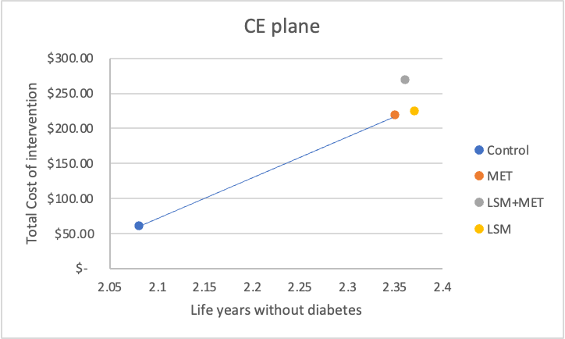

LSM – lifestyle modification; Met – metformin.

3.2 Probabilistic Sensitivity Analysis

The probabilities of avoiding diabetes for each intervention remained consistent across both deterministic and probabilistic sensitivity analyses (Shown in Figure S5 – S8). Additionally, the Area Under the Curve (AUC) values for life-years without diabetes were nearly identical in both types of analyses (Table 5).

Table 5. Area Under The Curve Values For Life-Years W/O Diabetes

|  |  |  |
| --- | --- | --- |
|  | Deterministic Analysis | Probabilistic Sensitivity Analysis |
| Control | 2.08 | 2.05 |
| LSM | 2.37 | 2.34 |
| MET | 2.35 | 2.32 |
| LSM + MET | 2.36 | 2.33 |

LSM- Life style modification, MET- Metformin

The LSM intervention was determined to be cost-effective compared with metformin, LSM + metformin and control, at threshold WTP above $550 per LYs without diabetes.

In the CEAF analysis, we considered a WTP range of $0 to 100K USD per unit of life without diabetes and results are reported in Figure 3. Results showed control to have the highest probability of being cost effective from WTP $0 to $300 after which LSM has the highest probability of being cost-effective from $300 to 100K USD. Given that the probabilities of avoiding diabetes for LSM, MET and LSM + MET were very close to each other suggesting uncertainty around a treatment being cost effective (Shown in Figure 3).

Figure 4. Cost-Effectiveness Acceptability Curves For Patients With IGT

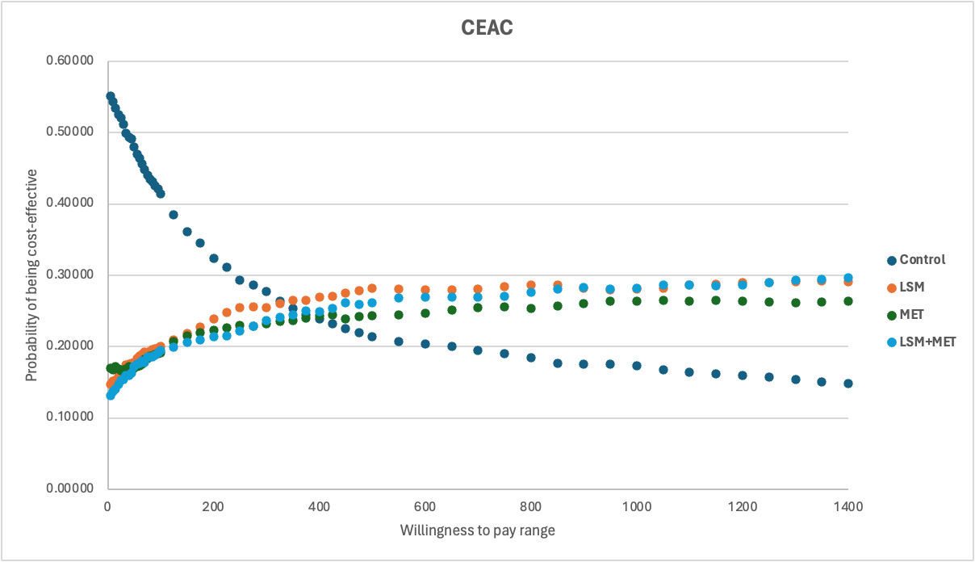

LSM- Life style modification, MET- Metformin, IGT- Impaired glucose tolerance

The CEAF analysis showed similar results with Control being cost effective for WTP ranging from $0 to $475 per LYs without diabetes and LSM being cost effective from WTP $500 to 3 million USD (Figure 4).

Figure 5. Cost-Effectiveness Acceptability Frontier For Patients With IGT

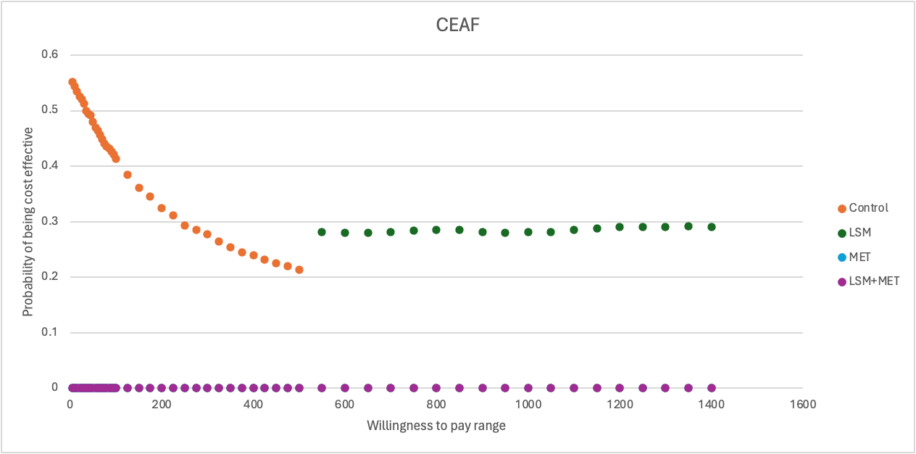

LSM - Life style modification, MET – metformin, IGT- Impaired glucose tolerance

3.3 EVPI and Net Loss

The graphical representation of population-level EVPI is presented in Figure 5. The value of information analysis depicts the amount a decision maker would be willing to pay knowing all the information influencing the decision of selecting a prefered treatment from this analysis. In other words, the EVPI is showing us how much a decision maker will lose if the optimal strategy is wrong.

Figure 6. Patient Level Expected Value Of Perfect Information  
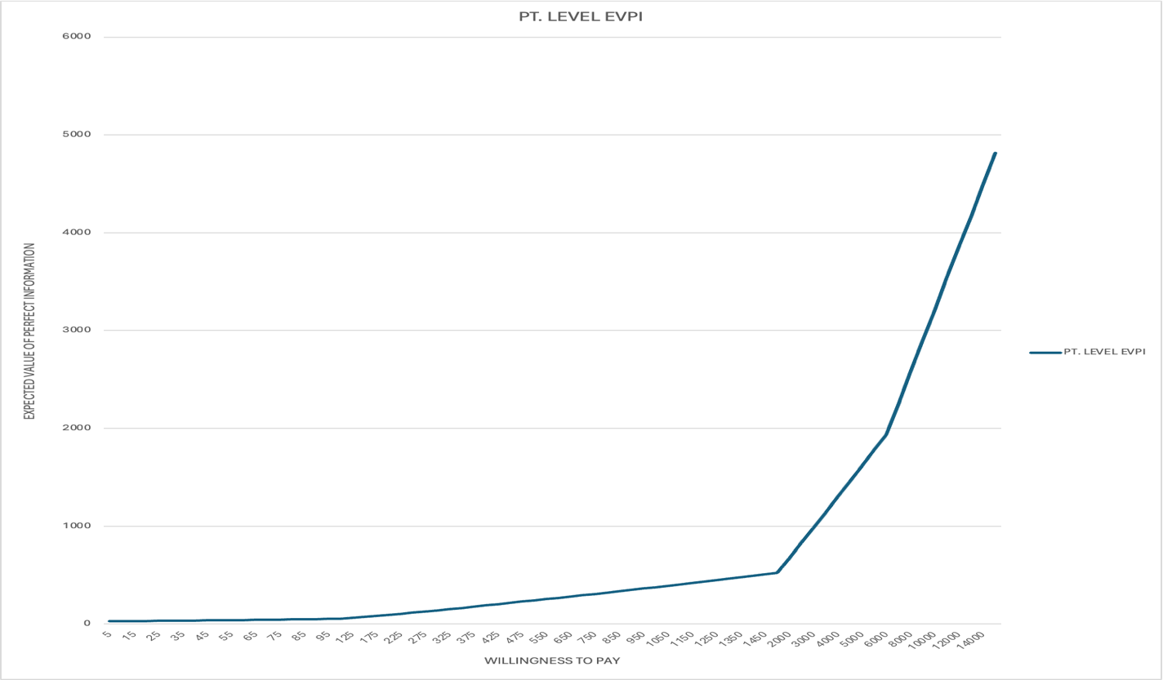EVPI – estimated value of perfect information

Figure 7. Population-Level Expected Value of Perfect Information  
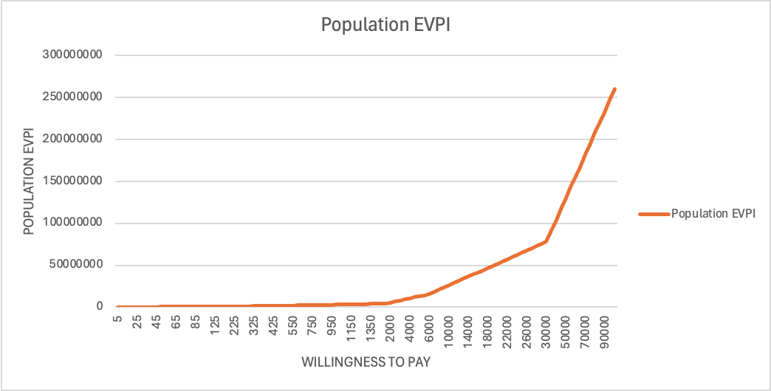EVPI – estimated value of perfect information

The Net Loss Curves illustrated the opportunity costs associated with selecting different treatment options at various WTPs. The net loss analysis revealed that up $550 WTP, the control arm exhibited the lowest NL and was the cost-effective alternative. However, beyond this threshold, LSM showed the lowest NL and was the most cost-effective treatment option (Figure 6).

Since the original article claimed that both LSM and MET were cost-effective, there is the potential of improper implementation given our revised conclusion that conflicts with it. If one were to choose MET at a WTP value of $1000, $5000, $10,000 and $50,000, the population level losses associated with that mistaken choice would be $3.1 million, $13.1 million, $26.1 million, and $143 billion, respectively.

Figure 8. Net Loss Curve

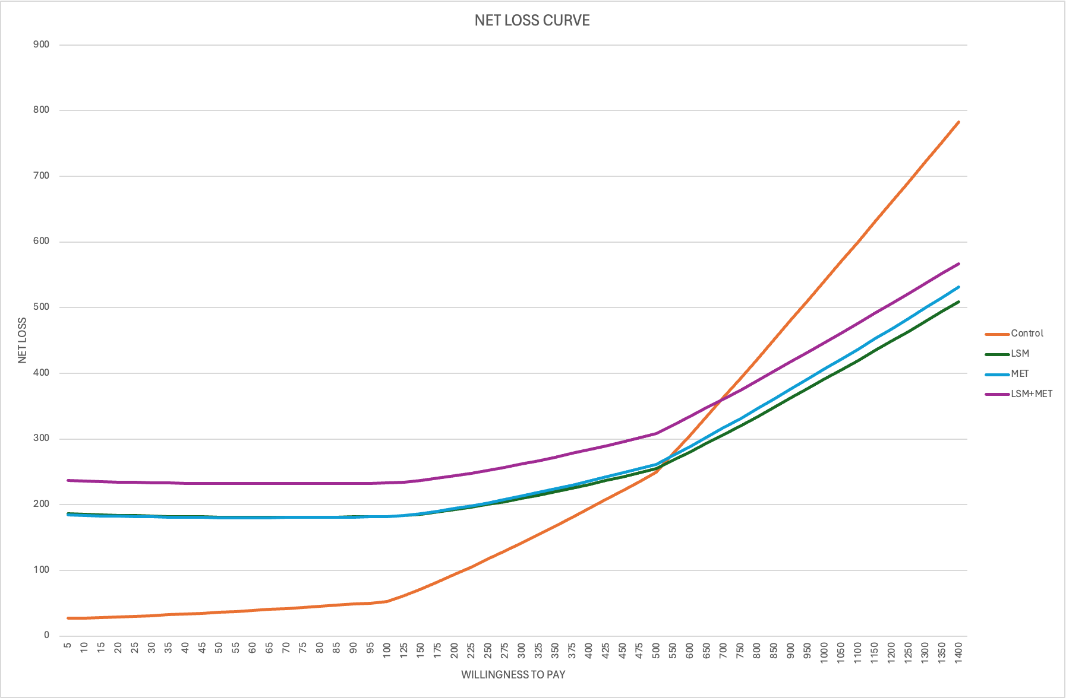

LSM- Life style modification, MET- Metformin

4. Discussion

In the original paper, Cost-effectiveness ranking was stated as LSM identified as most cost-effective, followed by metformin. And combination of LSM and metformin intervention is stated not superior to either used separately. Our ICER calculation led to LSM as the cost-effective option for preventing diabetes among patients with impaired glucose tolerance (IGT), if the willingness-to-pay (WTP) exceeds $565.15. Their Resource Allocation was LSM as first-line intervention due to resource efficiency and Metformin was suggested as an alternative if LSM fails in a subpopulation. Our choice of using NMB for better decision making leads to the average Area under the curve of LSM demonstrates the highest effectiveness of avoiding diabetes, followed by LSM + Metformin, Metformin, and control, consistent with deterministic analysis results. If the WTP is ≥ $519, LSM is the cost-effective treatment and if the WTP is < $519, control remains the cost-effective treatment option. After performing our probabilistic sensitivity analysis, followed by CEAC & CEAF, resulting in LSM having the highest probability of being cost-effective treatment (probability = 0.281) at the WTP of $550 and it remains cost-effective until 3 millions. We also performed EVPI analysis to achieve perfect information at WTP $550, achieving 100% confidence in LSM being the cost-effective treatment may require an additional expenditure of about $254 per one patient. Some of the limitations associated with the original paper can be the absence of analysis using Quality-of-life measures and the use of short-term cost-effectiveness, while the long-term benefits beyond trial period not being assessed.

5. Conclusion

The original CEA analysis reported that LSM, followed by Metformin to be the cost-effective treatment based on the ICER calculation. Our model showed that LSM is cost-effective if the WTP is more than $565, and $519 as per ICER, and NMB calculations, respectively using deterministic and probabilistic variables. Our model has demonstrated some variability. Hence, additional research is required on specific parameters to achieve more robust results for accurate decision making.

6. References

1. Ramachandran, A., Snehalatha, C., Yamuna, A., Mary, S., & Ping, Z. (2007). Cost- effectiveness of the interventions in the primary prevention of diabetes among Asian Indians: within-trial results of the Indian Diabetes Prevention Programme (IDPP). Diabetes care, 30(10), 2548-2552.
2. Ramachandran, A., Snehalatha, C., Mary, S., Mukesh, B., Bhaskar, A. D., Vijay, V., & Indian Diabetes Prevention Programme (IDPP). (2006). The Indian Diabetes Preventio Programme shows that lifestyle modification and metformin prevent type 2 diabetes in Asian Indian subjects with impaired glucose tolerance (IDPP-1). Diabetologia, 49, 289-297.
3. Glick H. Economic evaluation in clinical trials. Oxford; New York: Oxford University Press; 2007.

7. Appendix

# 7.1 AUC Calculation from survival curve

# Looking at the survival curve, we see three trapezoids for each year. To calculate the area for them we divided them into a triangle and a rectangle.

# Formula: AUC= Area of triangle (½*base x height) + Area of rectangle (length x breath)

# 7.1.1 Control Group

# Table S1. Probabilities of avoiding Diabetes in Control Group

|  |  |
| --- | --- |
| Year | Probability of avoiding Diabetes (1 – Probability of developing diabetes) |
| Year 1 | 0.76 |
| Year 2 | 0.58 |
| Year 3 | 0.45 |

Figure S1. Survival Curve for Control Group



Table S2. AUC calculation using Probability of avoiding Diabetes

|  |  |  |
| --- | --- | --- |
| AUC | Calculation | AUC Value |
| AUC at Year 1 | 0.5*(1 x (1-0.76))+ 1 x 0.76 | 0.88 |
| AUC at Year 2 | 0.5*(1 x (0.76-0.58))+ 1 x 0.58 | 0.67 |
| AUC at Year 3 | 0.5*(1 x (0.58-0.45))+ 1 x 0.45 | 0.51 |
| SUM of AUCs |  | **2.08** |

# 7.1.2 LSM Group

Table S3. Probability of avoiding Diabetes in LSM Group

|  |  |  |
| --- | --- | --- |
| Year | | Probability of avoiding Diabetes (1 – Probability of developing diabetes) |
| Year 1 | 0.84 | |
| Year 2 | 0.71 | |
| Year 3 | 0.60 | |

Figure S2. Survival curve for LSM Group

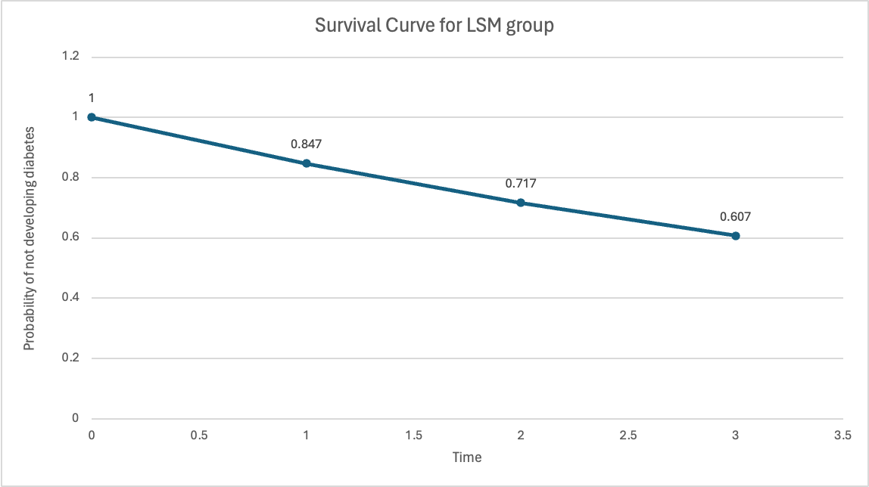

Table S4. AUC Calculation Using Probability of Avoiding Diabetes For LSM Group

|  |  |  |
| --- | --- | --- |
| AUC | Calculation | AUC Value |
| AUC 1 | 0.5*(1 x (1-0.84)) + 1 x 0.84 | 0.92 |
| AUC 2 | 0.5*(1 x (0.84-0.71)) + 1 x 0.71 | 0.78 |
| AUC 3 | 0.5*(1 x (0.71-0.607)) + 1 x 0.607 | 0.66 |
| SUM of AUCs |  | **2.37** |

# 7.1.3 Metformin Group

Table S4. Probability of Avoiding Diabetes in Metformin Group

|  |  |
| --- | --- |
| Year | Probability of avoiding Diabetes (1 – Probability of developing diabetes) |
| Year 1 | 0.841083259 |
| Year 2 | 0.707421048 |
| Year 3 | 0.595 |

Figure S3. Survival Curve for Metformin Group

Table S4. AUC Calculation Using Probability of Avoiding Diabetes For LSM Group

|  |  |  |
| --- | --- | --- |
| AUC | Calculation | AUC Value |
| AUC 1 | 0.5*(1 x (1-0.84))+ 1 x 0.84 | 0.92 |
| AUC 2 | 0.5*(1 x (0.84-0.707))+ 1 x 0.707 | 0.77 |
| AUC 3 | 0.5*(1 x (0.707-0.595))+ 1 x 0.595 | 0.65 |
| SUM of AUCs |  | **2.34** |

# 7.1.4 LSM + Metformin Group

Table S6. Probability of Avoiding Diabetes in LSM + Metformin Group

|  |  |
| --- | --- |
| Year | Probability of avoiding Diabetes (1 – Probability of developing diabetes) |
| Year 1 | 0.84 |
| Year 2 | 0.71 |
| Year 3 | 0.60 |

Figure S5. Survival Curve for LSM + Metformin Group

Table S7. AUC Calculation Using Probability of Avoiding Diabetes For LSM + Met Group

|  |  |  |
| --- | --- | --- |
| AUC | Calculation | AUC Value |
| AUC 1 | 0.5*(1 x (1-0.845))+ 1 x 0.845 | 0.92 |
| AUC 2 | 0.5*(1 x (0.845-0.715))+ 1 x 0.715 | 0.78 |
| AUC 3 | 0.5*(1 x (0.715-0.605))+ 1 x 0.605 | 0.66 |
| SUM of AUCs |  | **2.36** |

Figure S6. Probability Of Avoiding Diabetes At Year 1, 2, And 3 As Per Deterministic & Probabilistic Sensitivity Analysis – Control Group

Figure S7. Probability Of Avoiding Diabetes At Year 1, 2, And 3 As Per Deterministic & Probabilistic Sensitivity Analysis – LSM Group

Figure S8. Probability Of Avoiding Diabetes At Year 1, 2, And 3 As Per Deterministic & Probabilistic Sensitivity Analysis – Metformin Group

Figure S9. Probability Of Avoiding Diabetes At Year 1, 2, And 3 As Per Deterministic & Probabilistic Sensitivity Analysis – LSM + Metformin GROUP

7.2 Alpha and Beta Calculation-

7.2.1. Clinical Parameters:-

Considering

(α+β) = E(x) (1-E(x)) (1/s2) -1

E(x) = α/(α+β)

Where, E(x)= Mean/cumulative incidence reported and Standard error (S2) is calculated using 95% CI= mean + 1.96*(SE).

TABLE S8. Standard Error, Alpha & Beta Values For Cumulative Incidence Of Diabetes

|  |  |  |  |  |  |  |
| --- | --- | --- | --- | --- | --- | --- |
|  | Mean | 95% CI LL | 95% CI UL | SE | α | β |
| Control | 0.55 | 0.46 | 0.635 | 0.044642857 | 2.4992 | 2.0448 |
| LSM | 0.393 | 0.304 | 0.485 | 0.046173469 | 1.6373 | 2.5290 |
| MET | 0.405 | 0.32 | 0.497 | 0.045153061 | 1.7564 | 2.5804 |
| LSM + MET | 0.395 | 0.309 | 0.489 | 0.045918367 | 1.6607 | 2.5436 |

|  |  |  |  |  |
| --- | --- | --- | --- | --- |
|  | Probabilistic value | Total Costs | alpha | beta |
| Control | $66 | $61 | 1.00 | 61.00 |
| LSM | $267 | $225 | 1.00 | 225.00 |
| MET | $54 | $220 | 1.00 | 220.00 |
| LSM + MET | $163 | $270 | 1.00 | 270.00 |

Table S9. Alpha & Beta Values For Total Cost Parameter